SEO Project for Mario’s Pizzeria & Ristorante

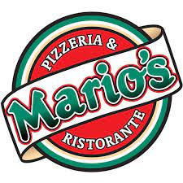

*A brief demonstration of some of my current search engine optimization skills*

By: Briana Barajas

**Introduction**

I will be conducting an SEO audit for Mario’s Pizzeria & Ristorante website. For reference, here is the link: https://mariospizzaabq.com/

For this project I will be using basic SEO tools such as:

* Screaming Frog
* Google Keyword Planner
* GT Metrix
* Moz Link Explorer

This audit has been divided into 3 main sections of SEO:

* On-Page SEO
* Technical SEO
* Off-Page

## On-Page SEO

**Website Header and Home Page Elements**

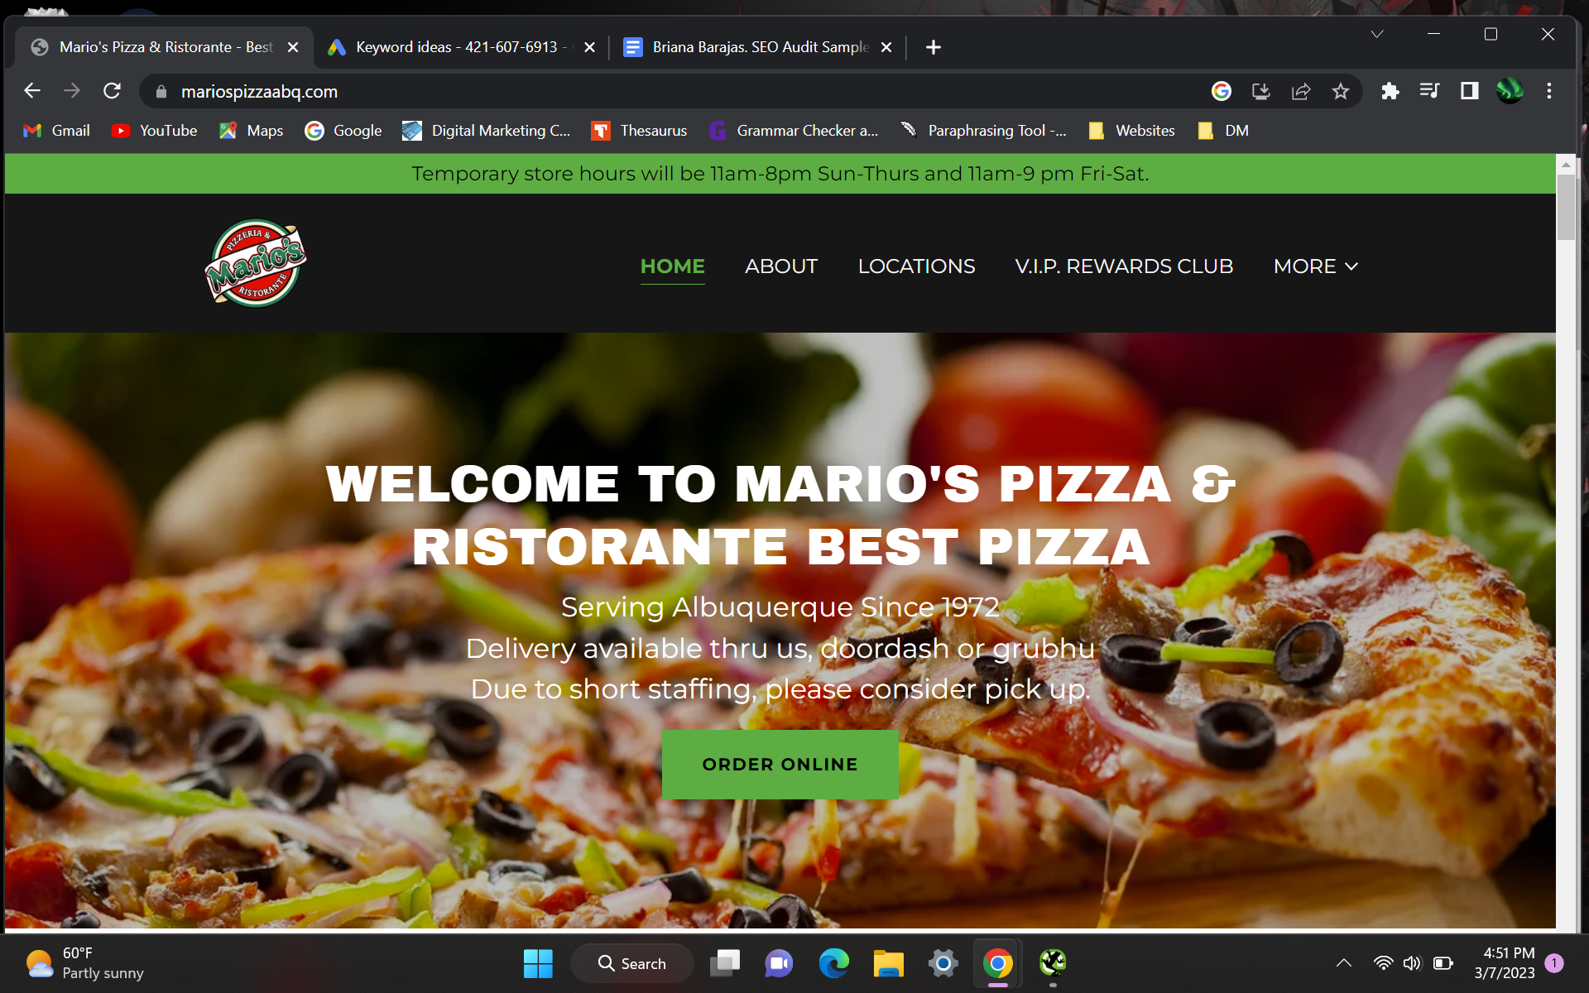

**Issues noted:** There is a CTA, but the description does have a few spelling errors. They are also offering delivery as another form of ordering. They do have restaurant hours, but they do not have a phone number on the main page. They do have multiple locations and the phone numbers are on this page as well. As much as it is important to have a location and phone number on the main page, it does help the user see that the location tab is on the top. The user can use this to see which location is closest to them.

**Solution:** I would first start off with correcting any spelling errors on the main page. I would also suggest that each location have its own landing page. Each location can then rank for specific keywords related to each restaurant.

**Keyword Analysis**

After learning what the client does on their website, I performed simple keyword research for the following: “pizza” “catering” “italian restaurant”

The following are screenshots of my research and I have highlighted the keywords that I would suggest for the client to include in their content so that they can rank for those terms on the Search Engine Results Page (SERP). I would pick “pizza restaurant” and “pizza places near me” since those are low competition, and the client can have a higher ranking on the SERP. Since they do offer catering services, I would include that keyword more on the website. I would also include “Italian restaurant” on the website more since they offer authentic Italian dishes.

I would mention that they specialize in pizza and Italian food and give some examples of those items on the main website. Even though their catering services are listed on the home page, they are further down, so visitors must scroll down to actually view them. I would advise building a new page that separates the catering menu and includes the various catering packages. Including keywords related to catering and the different packages they offer are also relatable keywords to use. I would also add the catering menu on that page because it is included in the ordinary menu, so it might confuse the user.

(*Screenshots from Google Keyword Planner*):

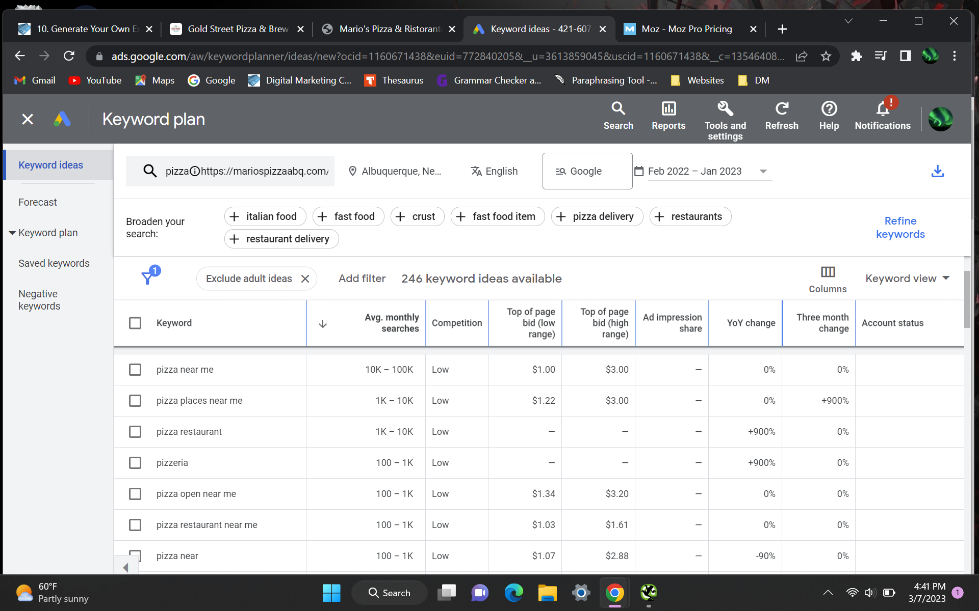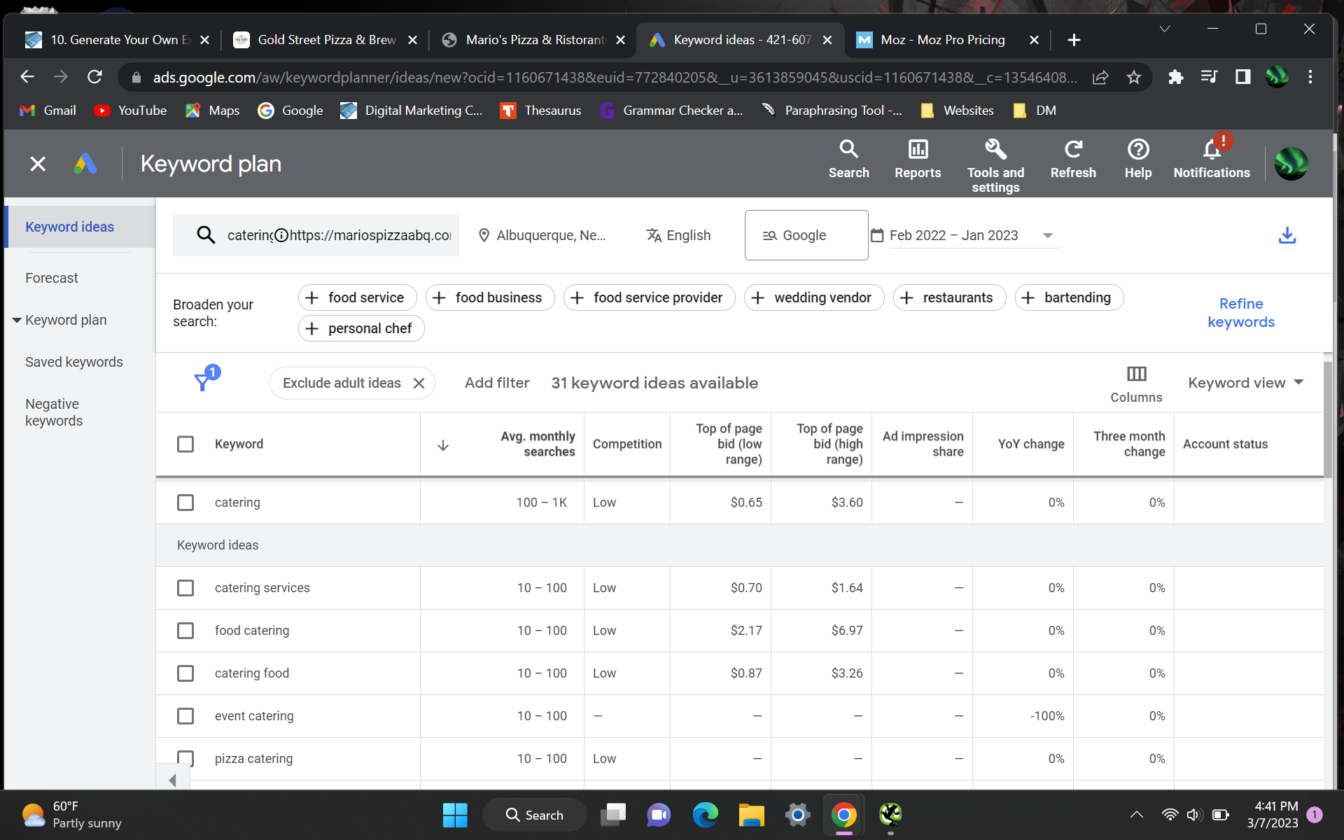



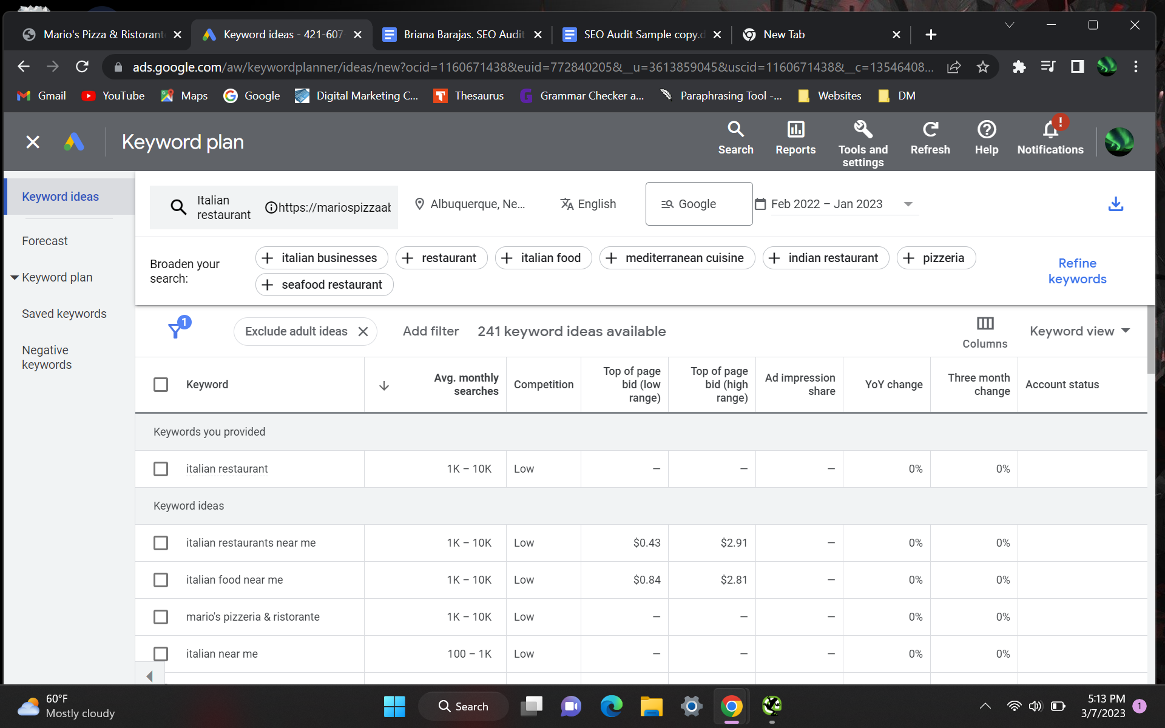



**Title Tags**

A title tag is an HTML element that specifies the title of each page. It is a clickable link that will take the user to that specific page. It should include keywords that are relevant to the business, and be under 30 characters. It is important in SEO because title tags tell the search engine results page (SERP) and user what the page is about.

(*Screenshot from Google*):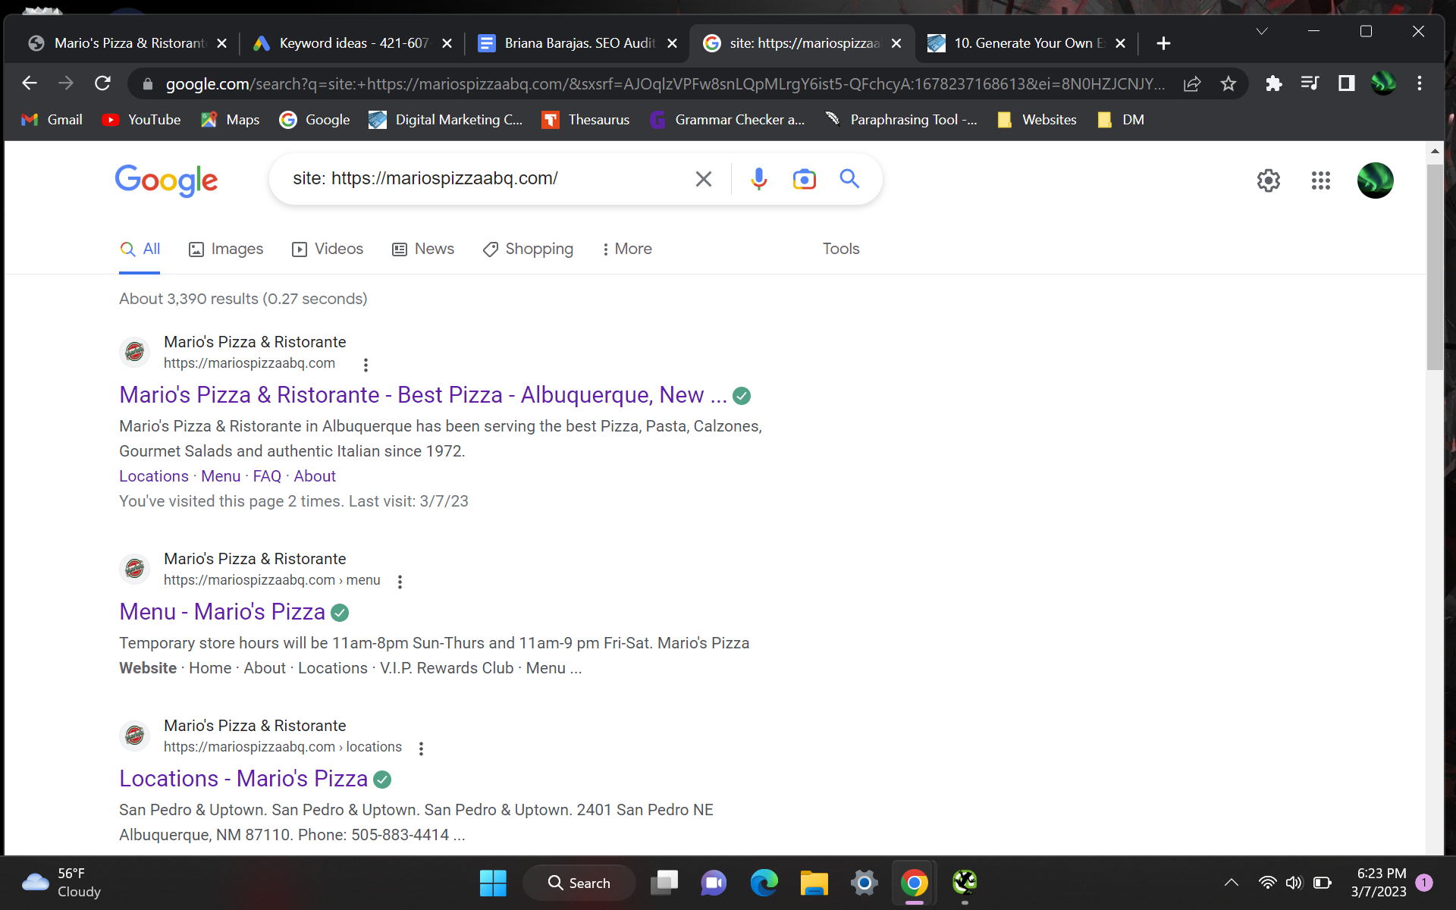

(*Screenshot from Screaming Frog*):

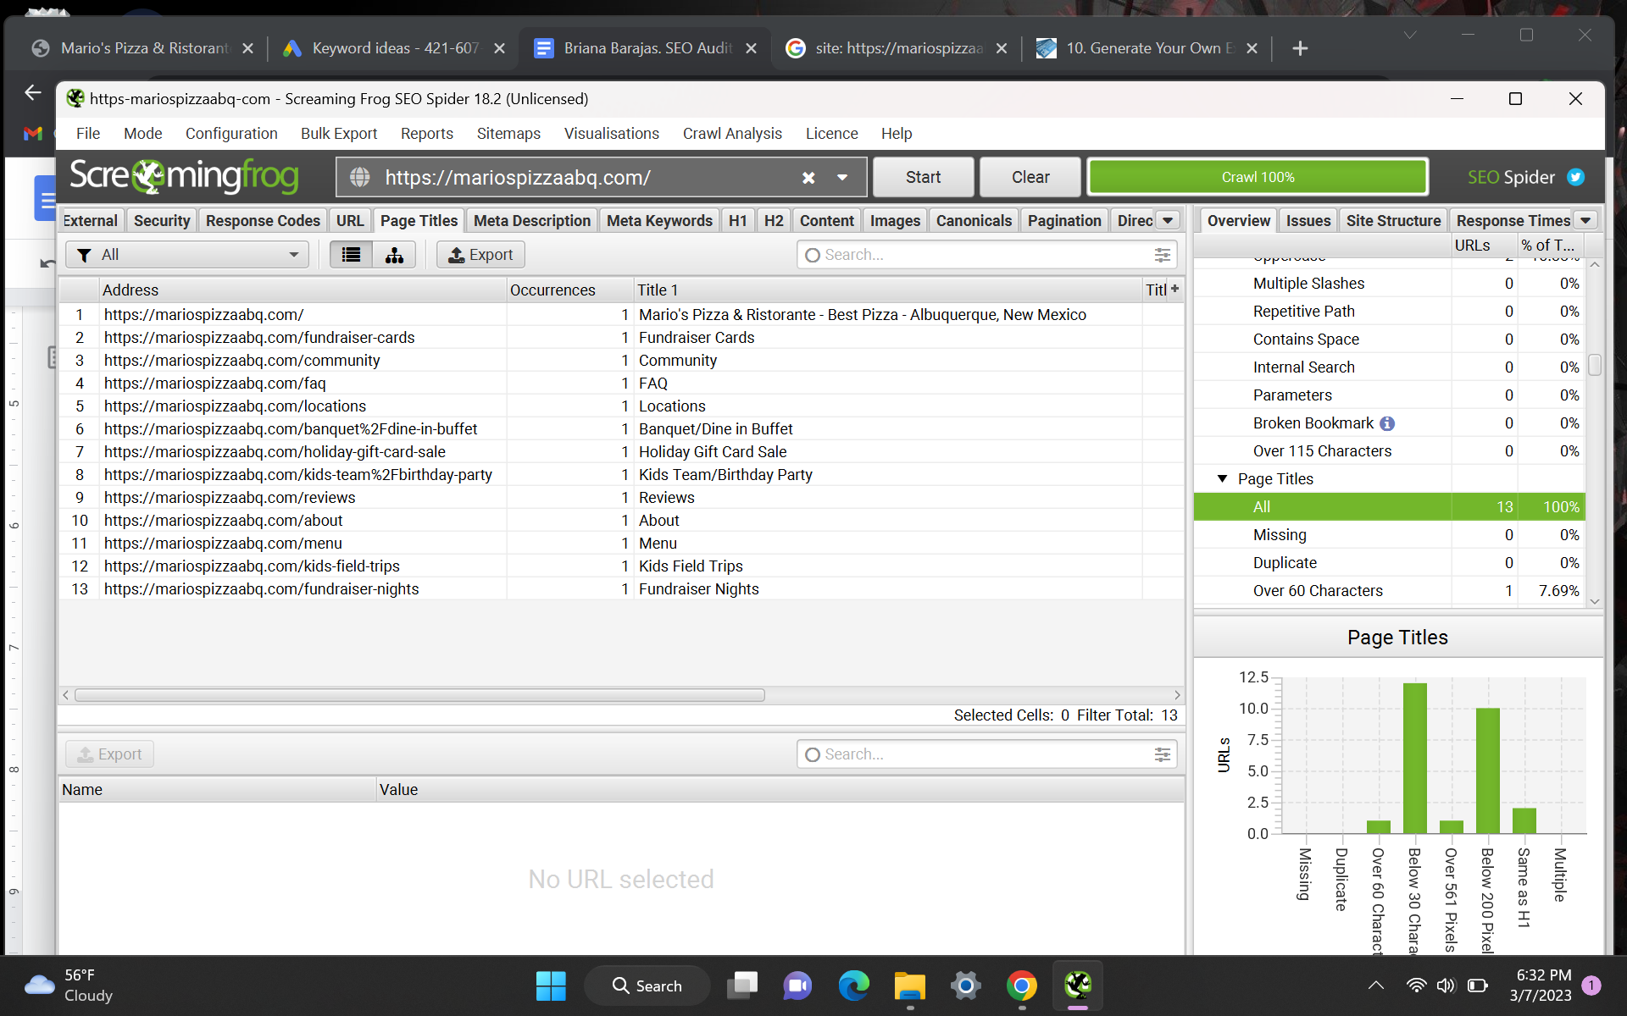

**Issues noted:** The title tag for the home page is using one of the keywords that can optimize the website. However, there are no other keywords mentioned in other title tags. They do have a ‘locations’ title tag, which is beneficial for the user to see the other locations.

**Solution:** As a further service they provide, I would advise the client to develop a page for catering services. That would include an additional title tag with a crucial keyword for the website. Without exceeding the allotted 30 characters, the menu title tag could list some of the meals they serve.

**Example for the Menu Page:** Authentic Italian Menu

**Meta Descriptions**

Meta descriptions are another HTML element that describe and summarize the content of the page to again help the SERP and the user understand what the website is about. It is important in SEO because it can help with click through rate, which in turn helps ranking factors of the website.

**Note**: Google can sometimes re-write your meta descriptions if it feels like the ones you have are not currently optimized or relevant.

(*Screenshot from Google*):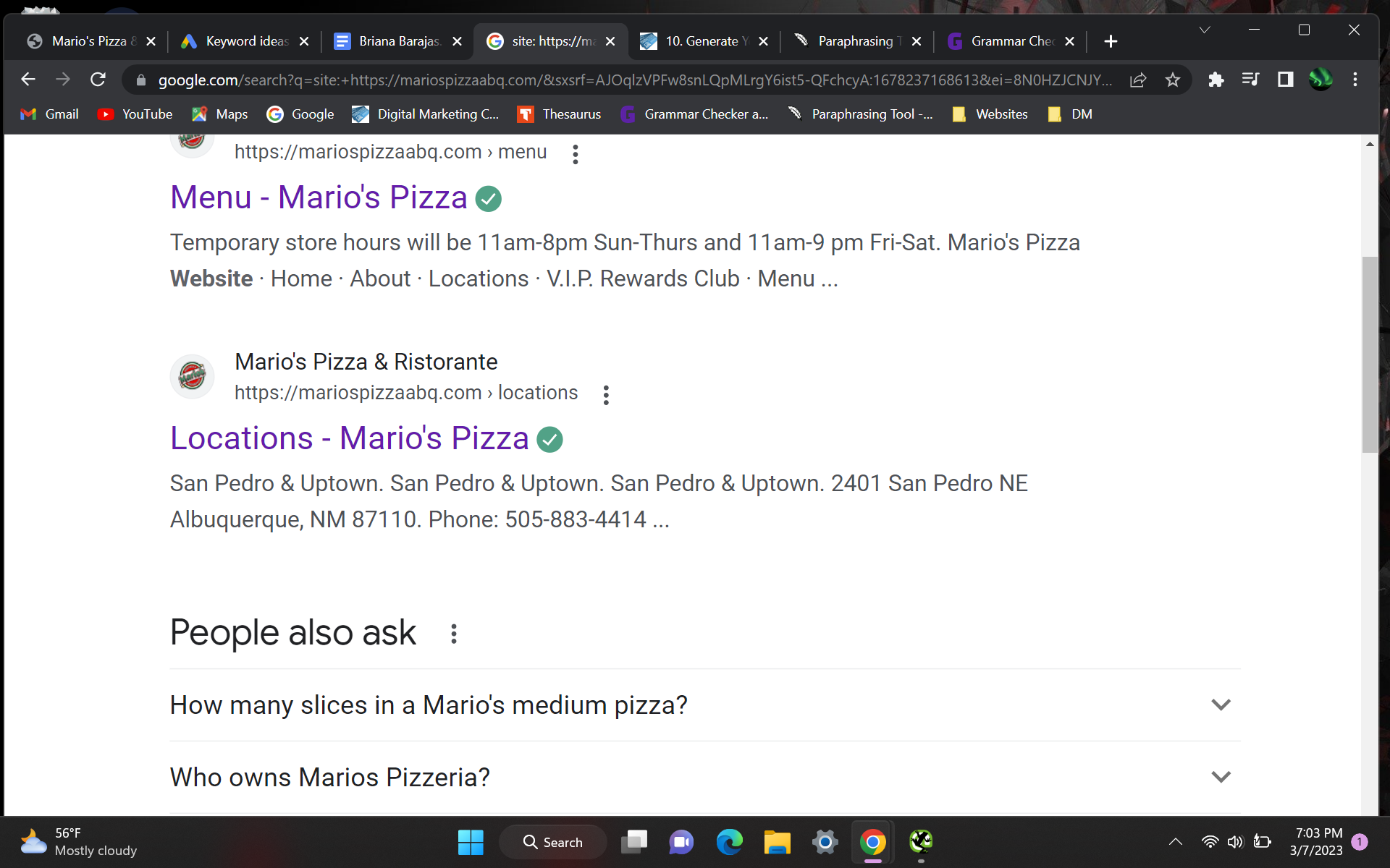

(*Screenshot from Screaming Frog*):

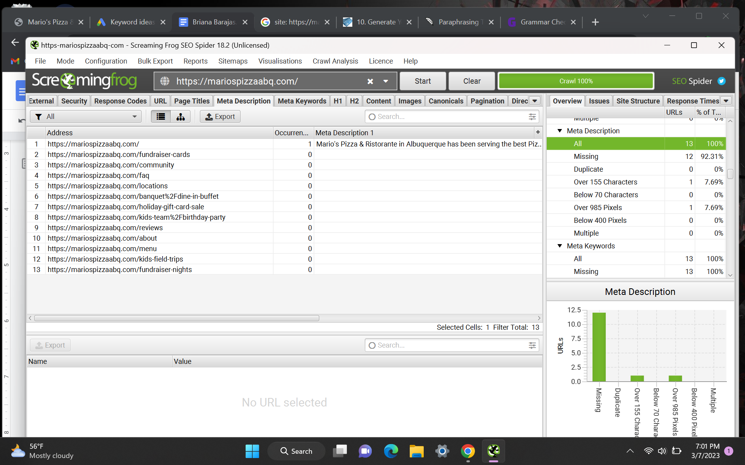

**Issues noted:** Twelve missing meta descriptions are seen from the Screaming Frog crawl. The only page with a meta description is the home page. I think it is optimized because it clarifies the purpose of the website and contains relevant keywords.

The menu page's meta description drew my attention on the Google search. They have a variety of menu items that they can rank for, however there are no keywords in the description.

**Solution:** I would recommend writing unique meta descriptions that are relevant to the page without going beyond 160 characters. It would help optimize the SERP and encourage the user to click on the client’s website. Adding keywords will also help Google rank the specific pages to what people are searching for.

**Example for the Menu Page:** See our menu of authentic Italian cuisine: Gourmet Pizzas, Calzones & Pasta Dishes

**Header Tags**

Header tags are HTML elements that are used to identify headings and subheadings within a page. They help the search engine read and understand content that is separate from other types of text.

(*Screenshot from Screaming Frog*):

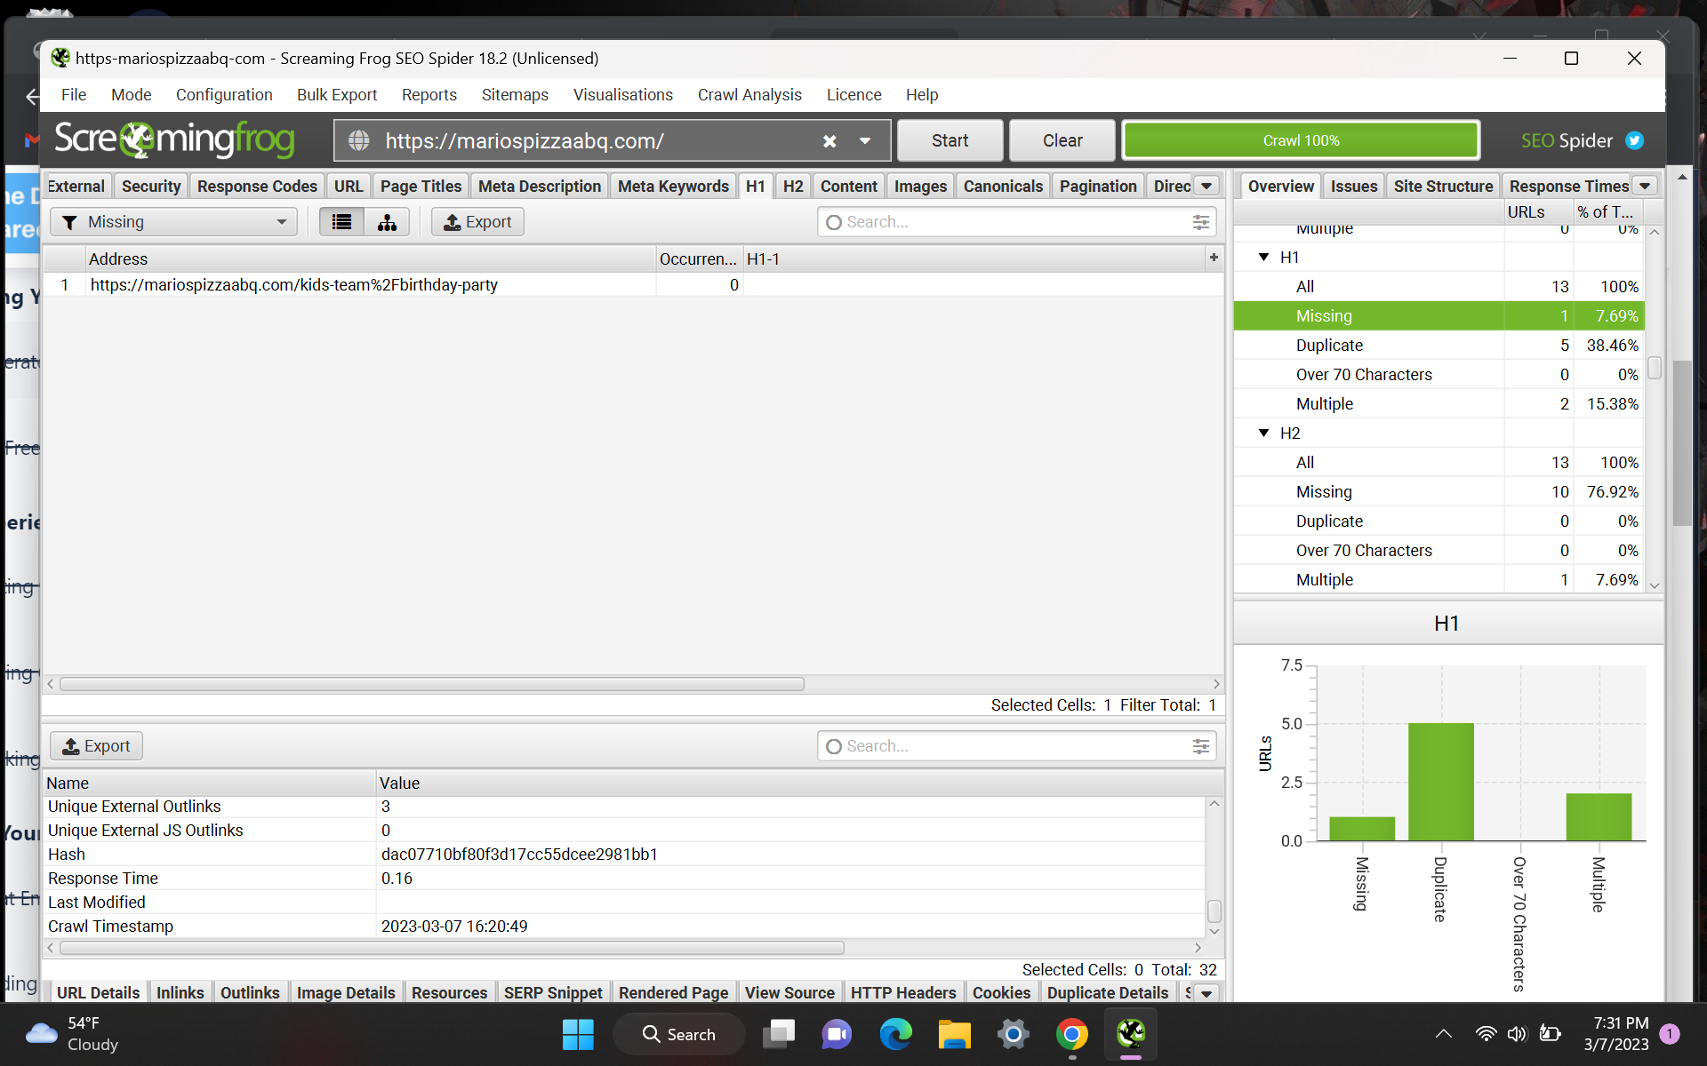

**Issues noted:** There is only one H1 tag that is missing, however there are duplicate H1 tags. There are also ten missing H2 tags. When going to the missing H1 tag page, I did notice the page was blank.

**Solution:** I would recommend to change the duplicate H1 tags to a relatable keyword that is relevant to the page. Depending on what each page is describing, I would add H2 tags. It is important to make the H1 tags readable for users without overusing keywords.

I would also recommend writing unique, relevant content for the missing H1 page, and then creating an H2 tag if necessary. In order for Google to understand what the page is about and to improve the ranking algorithm, it is important to produce unique content using relevant keywords.

**Example for the Dine in Buffet Page:** “Dine in Buffet” could be assigned as the H1 tag. “Catering” could be the H2 tag. This page would have content relating to both buffet and catering services that the client offers.

## Technical SEO

**Site Speed Analysis**

Site speed is important for ranking on the SERP. A website should typically load in under three seconds. If a website takes a long time to load, this will discourage the user from visiting that website and it will affect their ranking performance.

(*Screenshots from GT Metrix*):

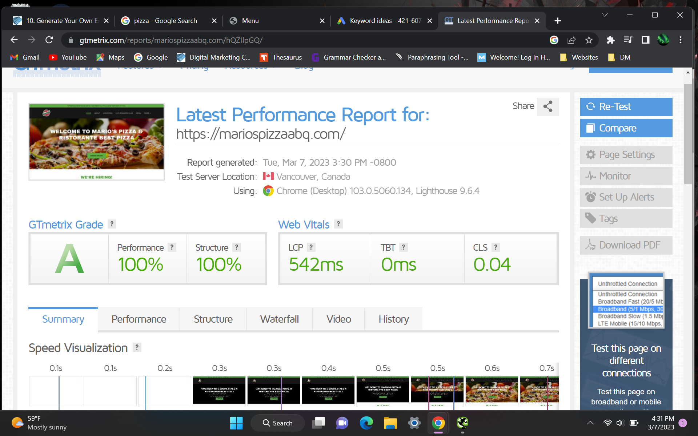

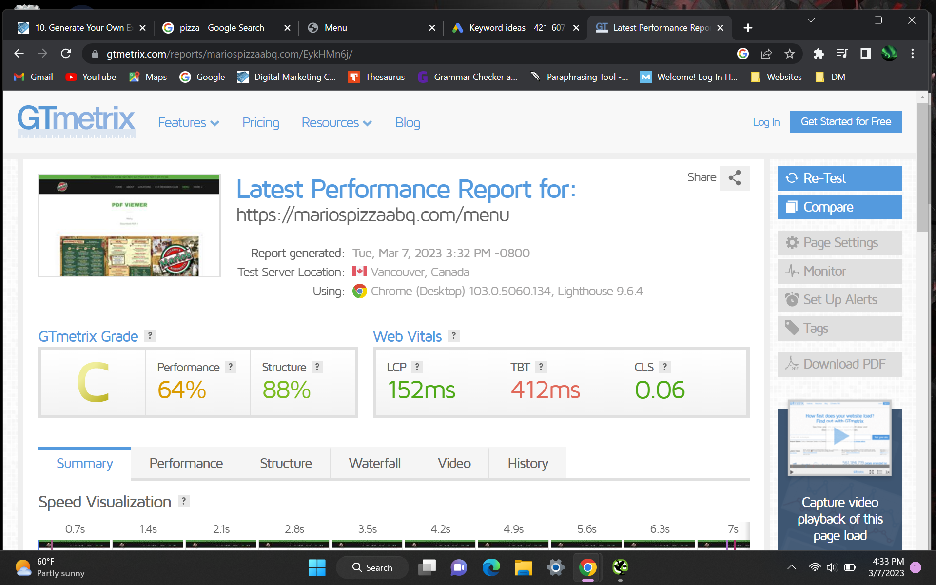

**Issues noted:** After testing the website through GT Metrix, it does have a good score. The website does load quickly. I did test the menu page (screenshot included above) because that page took longer than others to load. That score shows that some improvements are needed for that specific page.

**Solution:** The menu page is the only one I noticed that took longer to load. After looking at GT Metrix, I would recommend optimizing the page to compress the menu pages for the website to load faster. They do offer the option to download the menu, so I would improve the download speed of the pdf for it.

**404 pages or Broken Links**

A 404 page is a response code given to a broken page or link. It indicates that the page cannot be found. It negatively affects a website because it will discourage users from engaging with that site. It also makes it harder for a search engine to crawl your website. This both harms a website’s search engine rankings.

(*Screenshot from Screaming Frog*):

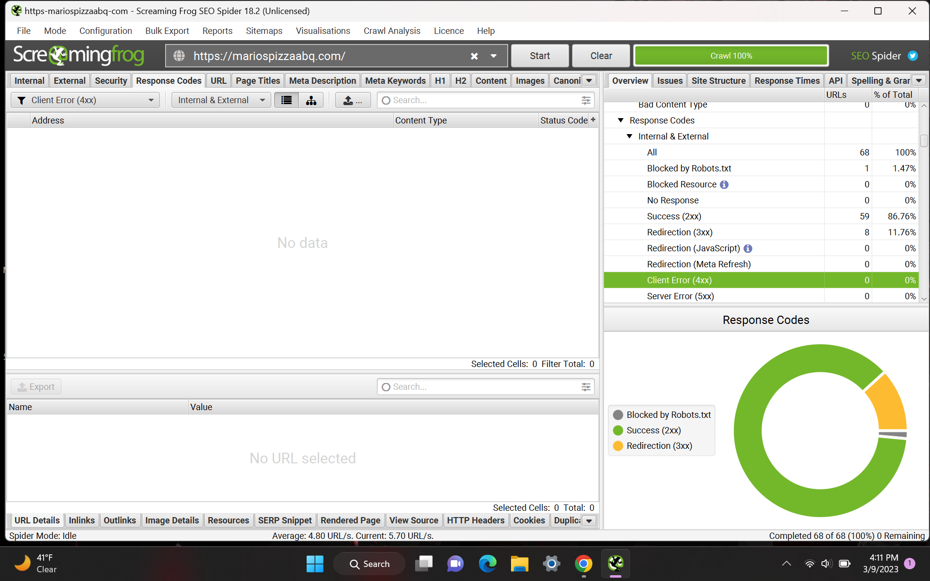

**Issues noted:** There are no broken links on the website.

If I were in charge of maintaining a website and I discovered a broken link, I would try to fix it. Finding the broken link and the page where it is broken would be my first step. I would then update the URL or completely remove the link. After that, I would check its functionality both manually and with a link checker tool. This will improve user experience and maintain the website's functionality by routinely looking for and repairing broken inks.

**Schema Markup**

Schema markup is a semantic code that is placed on a website to help the search engines return more informative results for users.

<https://search.google.com/structured-data/testing-tool/u/0/>

(*Screenshot from Schema Validator*):

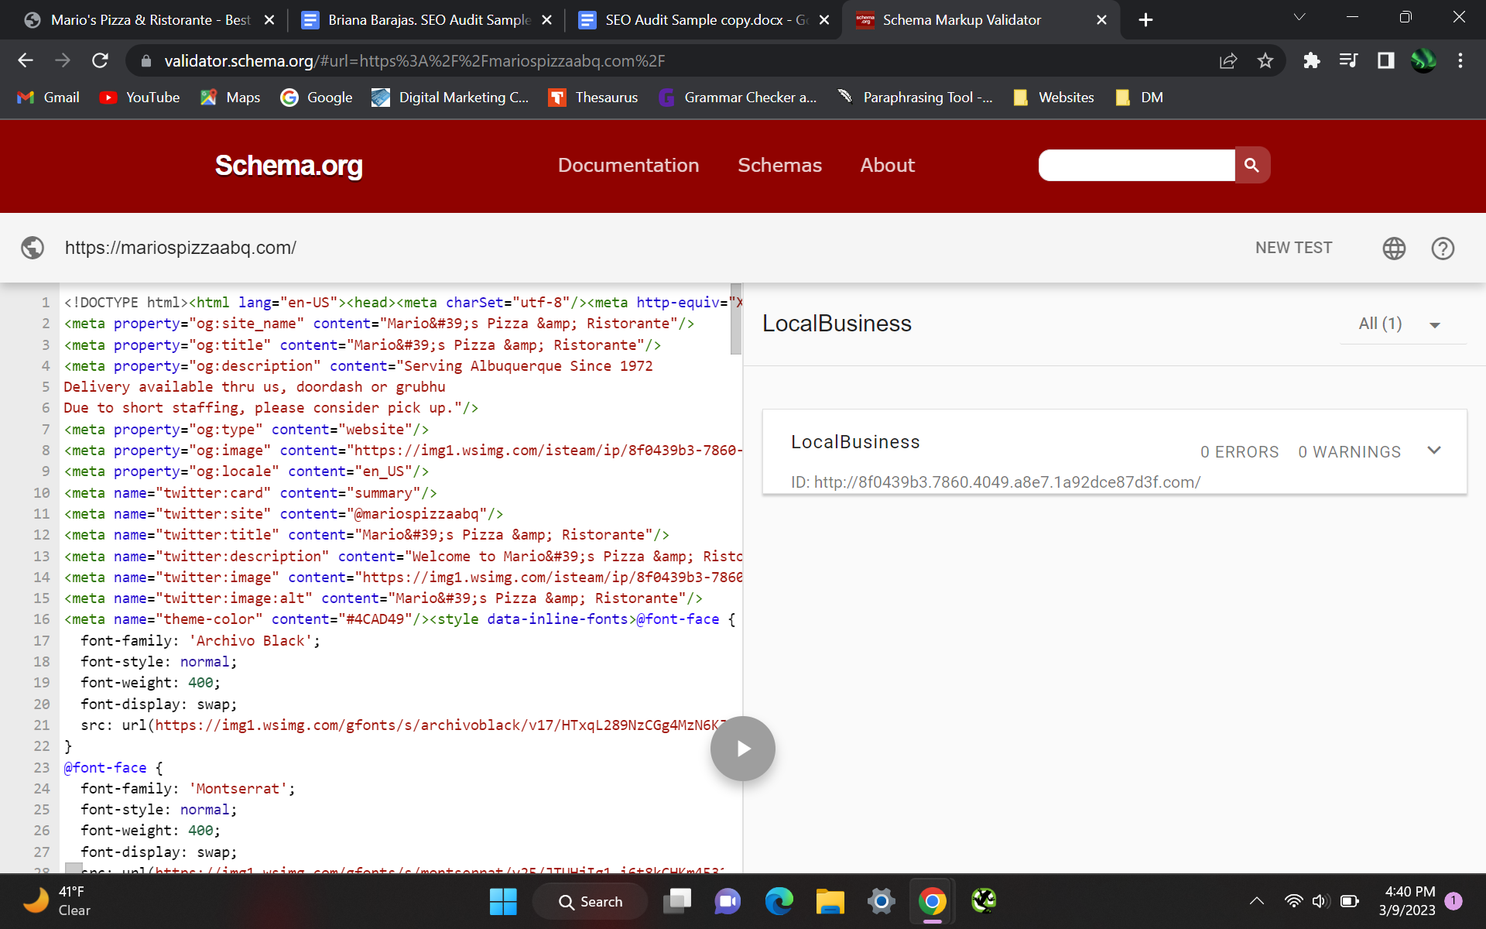

**Issues noted:** There are no issues noted. The schema markup detected is for the main page of the website. This helps the SERP understand what the website is about and can display this website on a user’s query.

## Off Page SEO

**Competitive Analysis**

By doing a quick search on Google for the keywords “pizza restaurants” and Moz’s Link explorer, we can quickly see who the competition is for Mario’s Pizzeria and Ristorante.

Competitor in that area: Pizza 9

(*Screenshot from Google*):

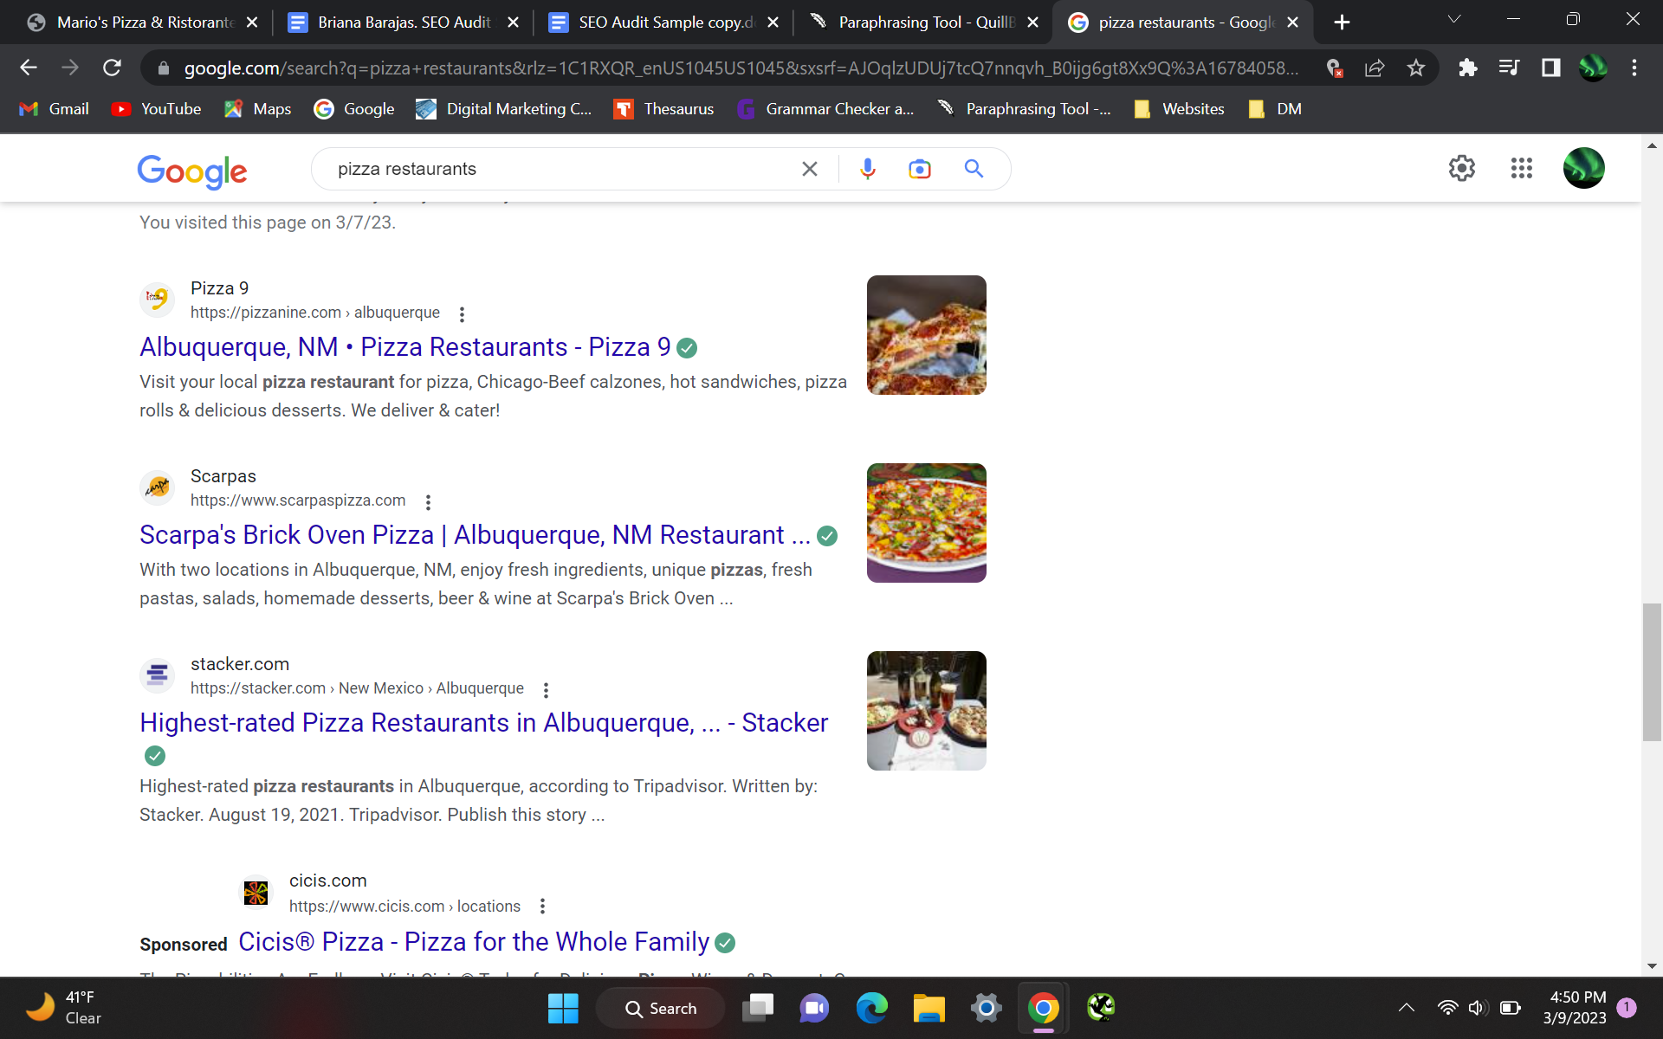

(*Screenshot of competitor stats on Moz Link Explorer*):

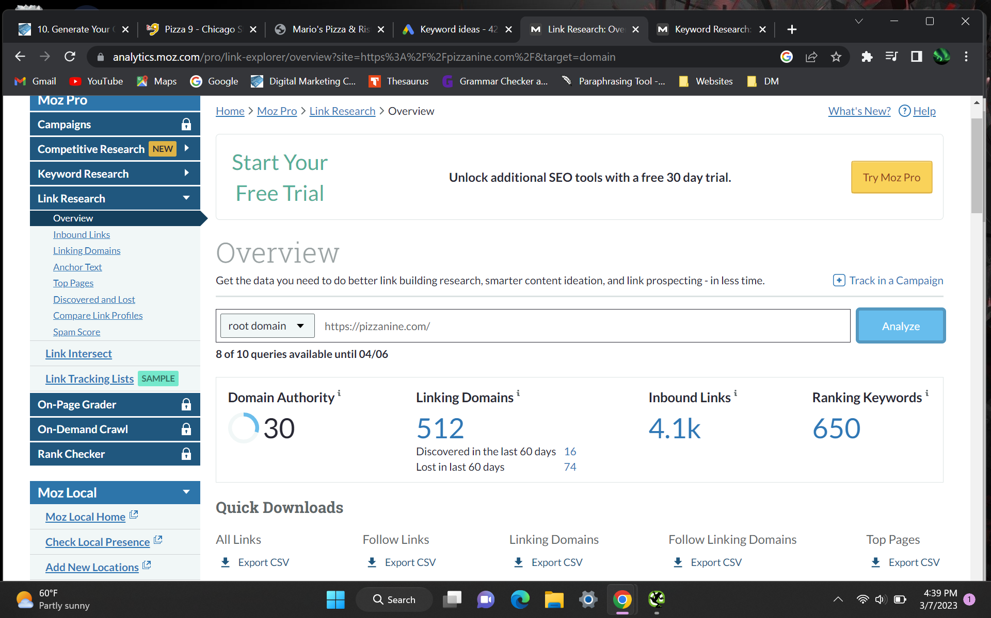

(*Screenshot of auditing website stats on Moz Link Explorer*):

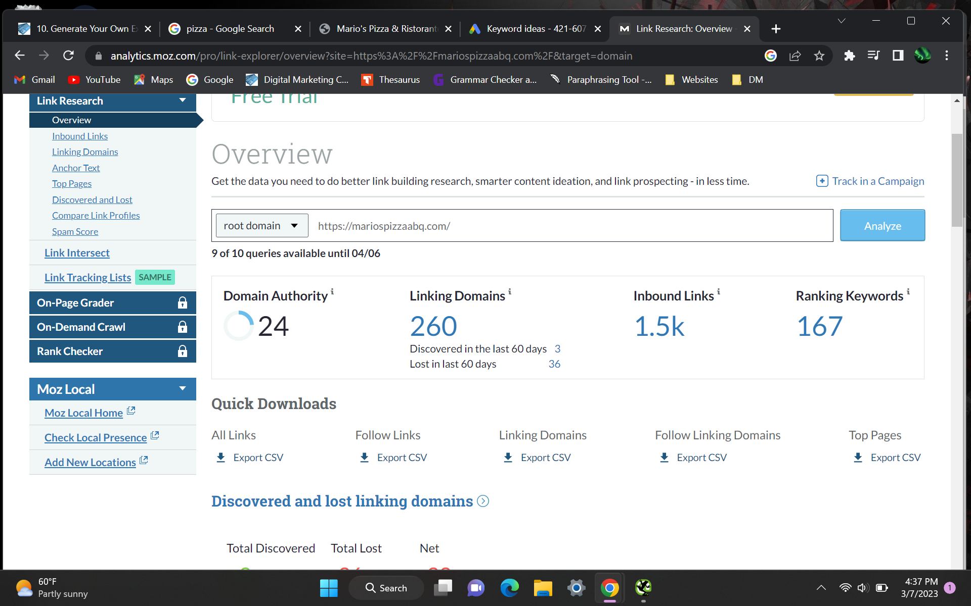

**Issues Noted:** According to the data above, the competitor Pizza 9 has a higher domain authority. They have 512 linking domains while the client Mario’s Pizzeria and Ristorante only has 260 linking domains. Pizza 9 has 650 ranking keywords while Mario’s Pizzeria and Ristorante has 167 keywords.

**Solution:** I would recommend improving the website for better on-page keyword targeting. Adding a page that has more relevant content would benefit the optimization of the website. Reaching out to other websites/blogs and creating content for them to link back to the client would also benefit the ranking of the client’s website.

**Final Thoughts**

Overall, the website is developed fairly well. The domain authority is relatively high which helps with optimization.

I would recommend editing the title tags and meta descriptions to improve the relevance of the information it describes. Additionally, I would separate some of the text that is related to particular keywords (i.e. catering services). This will aid in keyword targeting and may increase website traffic. There is room for improvement in the menu page speed. Despite the fact that they have a schema markup, I advise changing it so the search engine can better comprehend the page.

Implementing these changes can improve the domain authority, website’s traffic, and overall optimization of the website itself.